Name: Balu S

Reg No: 192424230
Course Name: Computer Networks for Software Application Code: CSA-0713

- Configuration of Network Devices using Packet Tracer tools (Hub, Switch, Ethernet, Broadcast)

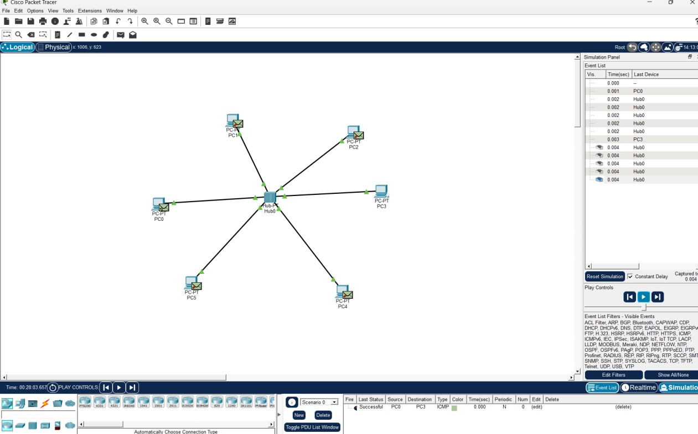

- Design and Configuration of Star Topologies using Packet Tracer Star Topology using Hub:

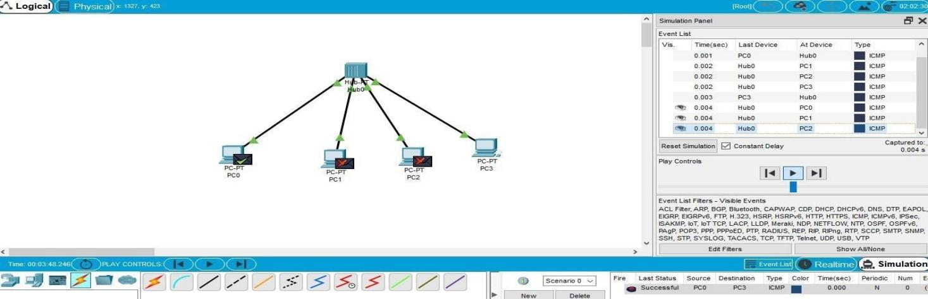

- Design and Configuration of BUS Topologies using Packet Tracer.

Bus Topology using Hub:
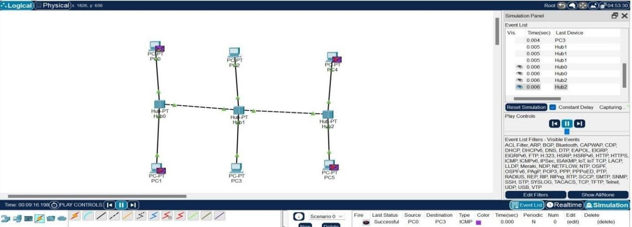

- Design and Configuration of RING Topologies using Packet Tracer

Ring Topology using Switch:
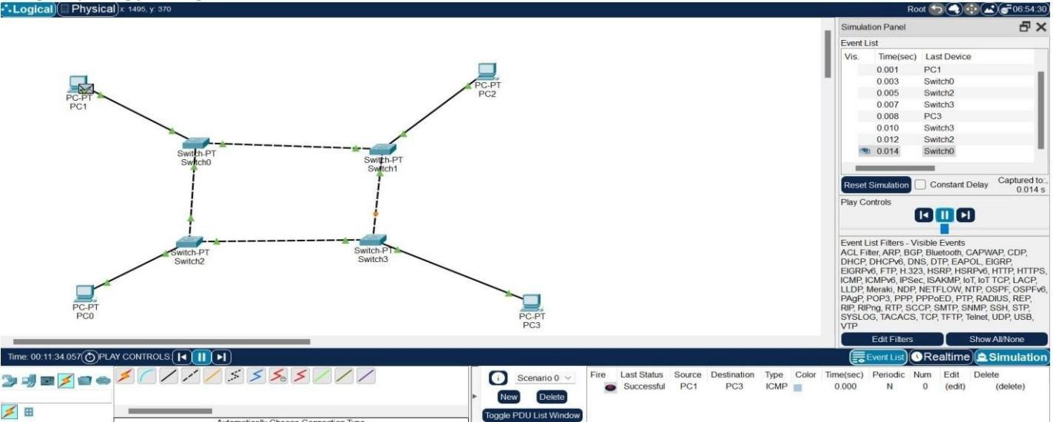

- Design and Configuration of Mesh Topologies using Packet Tracer

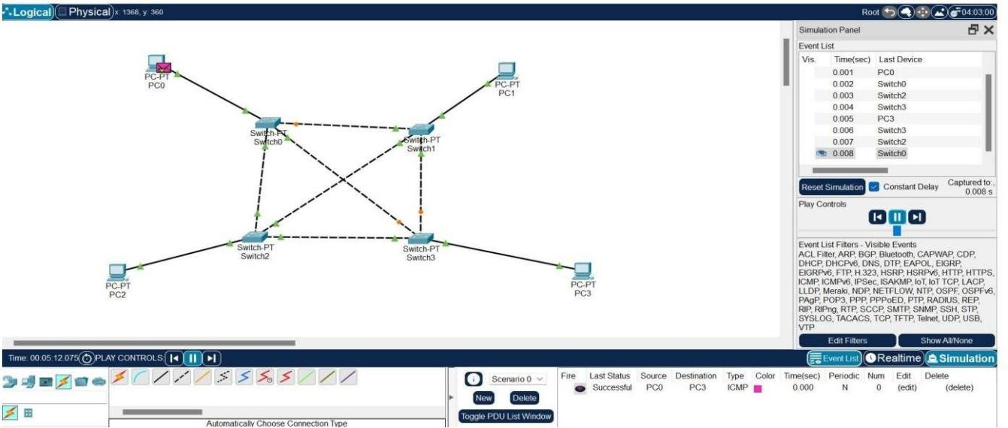
Mesh Topology using Switch:

- Design and Configuration of Tree Topologies using Packet Tracer.

Tree Topology using Hub:

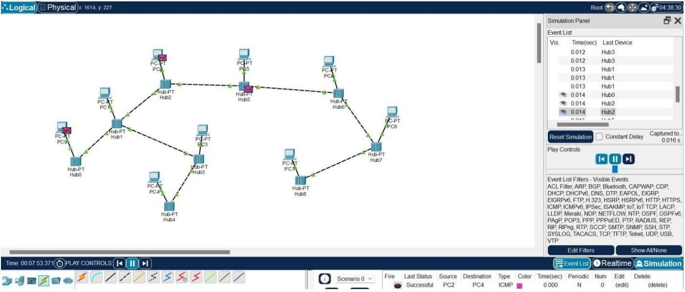

- Design and Configuration of Hybrid Topologies using Packet Tracer.

Hybrid Topology using Switch:

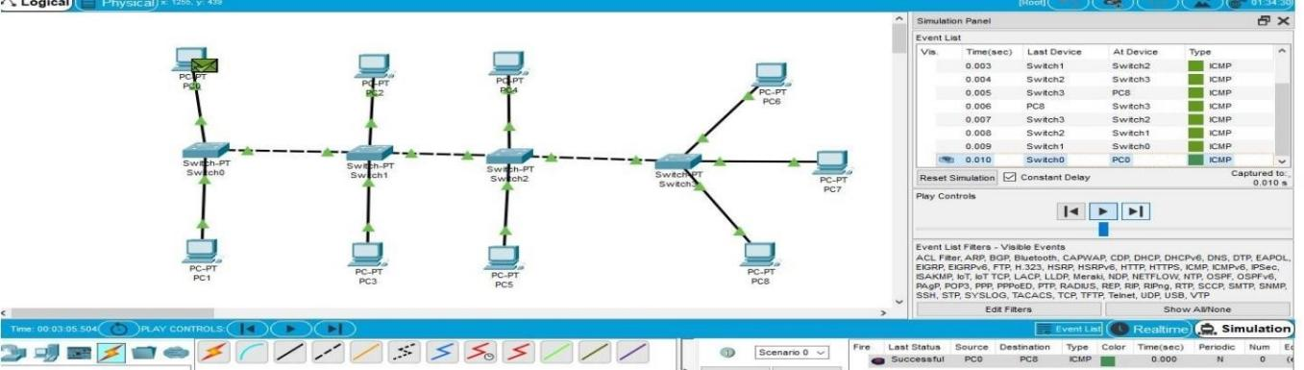

- Data Link Layer Traffic Simulation using Packet Tracer Analysis of ARP.

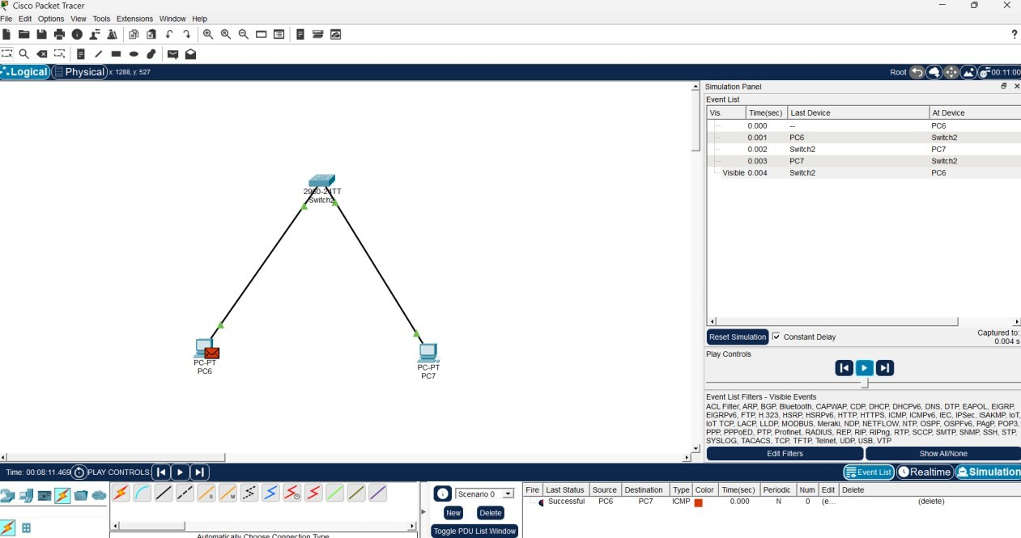

- Data Link Layer Traffic Simulation using Packet Tracer Analysis LLD

